|  |  |
| --- | --- |
| Course Name | ITD 2313 – Script Programming |
| Instructor | Mark Pranger |
| Student Name | Josh Jones |
| Due date | May 19 |
| Grade | <grade earned here> |
| Grading Comments | <instructor comments here> |

Page 55:

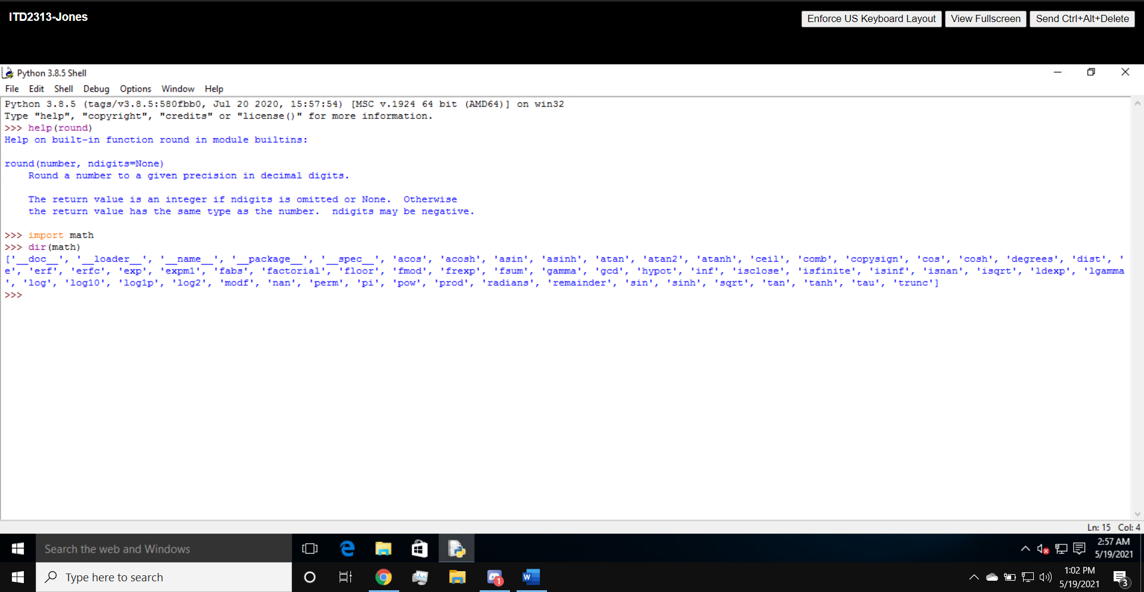

Page 56 and 57:

NOTE: I have downloaded the file for the taxform part for pages 56 and 57 but it does not seem to be working and I am not sure as to why.

